|  |  |  |
| --- | --- | --- |
| **Report of** | **Meeting** | **Date** |
| Director of Finance and Section 151 Officer | Governance Committee | 29th November 2022 |



# TREASURY MANAGEMENT MID-YEAR REVIEW 2022/23

|  |  |
| --- | --- |
| Is the report confidential ? | No |
| Is the decision key ? | No |

|  |
| --- |
| Purpose of report |
| 1. To report on Treasury Management performance and compliance with Prudential Indicators for the period ended 30th September 2022. 2. To present monitoring figures for the quarter ended 30th September 2022, including updated interest rate forecasts from Link Asset Services. |
| Recommendation to Governance Committee |
| 1. That the report be noted.   **Reasons for recommendations**   1. Production of a Mid-Year Report is a requirement under the Treasury Management Code of Practice.   **Other options considered and rejected**   1. Not applicable   **Corporate priorities**   1. The report relates to the following corporate priorities: |

|  |  |
| --- | --- |
| **An exemplary council** | **Thriving communities** |
| **A fair local economy that works for everyone** | **Good homes, green spaces, healthy places** |

## Background to the report

1. At its meeting on 23rd February 2022, Council approved the Treasury Management Policy Statement; Prudential Indicators; Investment Strategy; and the Annual Minimum Revenue Provision (MRP) Policy for 2022/23.
2. The Treasury Management Annual Report for 2021/22 was presented to Governance Committee on 26th July 2022.
3. The Code of Practice for Treasury Management requires Councils to review their treasury strategies and activities half yearly. This report satisfies that requirement.

## Capital Expenditure and Financing 2022/23

1. The Council undertakes capital expenditure on long-term activities. These activities may either be:

* financed immediately through the application of capital or revenue resources (capital receipts, capital grants, revenue contributions etc.), which has no impact on the Council’s borrowing need; or
* if sufficient financing is not available, or a decision is taken not to apply resources, the capital expenditure will give rise to a borrowing need.

1. Capital expenditure is monitored monthly and reported to Cabinet every quarter.
2. The report for the quarter ended 30th September 2022 was considered by Cabinet on 16th November 2022 and highlighted a reduced forecast borrowing requirement for the year of £9.765m compared to an original forecast of £11.102m (£17.426m at July 2022).

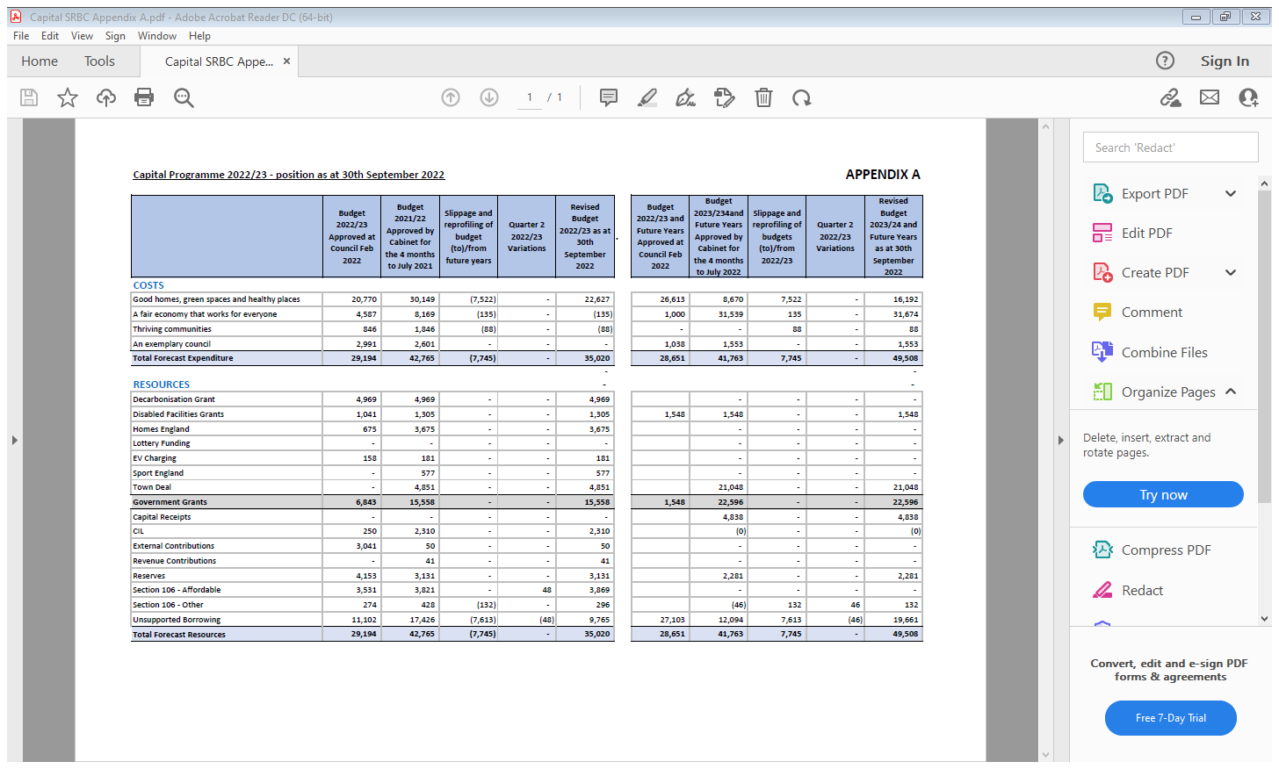

Full details are outlined in the report to Cabinet 16th November 2022; 2022/23 Capital Programme and Balance Sheet Monitoring Report position at 30th September 2022

# Capital Financing Requirement 2022/23

1. The Council’s underlying need to borrow for capital expenditure is termed the Capital Financing Requirement (CFR). This figure is a gauge of the Council’s indebtedness. It represents the unfinanced capital expenditure in 2022/23 plus unfinanced capital expenditure from prior years which has not yet been paid for by revenue or other resources.
2. The CFR is not matched in full by external borrowing, as the Council has “under borrowed” by using its own cash balances to finance capital expenditure. There is some loss of interest as a result, but had external loans been taken, then the interest payable would have been at a higher rate. Use of the Council’s own cash helps to achieve savings in net interest.
3. The Council’s underlying borrowing need is not allowed to rise indefinitely. Statutory controls are in place to ensure that capital assets are broadly charged to revenue over the life of the asset. The Council is required to make an annual revenue charge, called the Minimum Revenue Provision (MRP), to reduce the CFR. This is effectively a repayment of the borrowing need.
4. The Council’s CFR for the year is shown below and represents a key prudential indicator;

|  |  |  |
| --- | --- | --- |
| **Table 2 - Capital Financing Requirement** | **2021/22**  **Outturn**  **£’000** | **2022/23**  **Forecast as at 30/9/22**  **£’000** |
| Opening CFR | 2,500 | 3,509 |
| Increase in Borrowing (Table 1) | 1,307 | 9,765 |
| Less MRP | (298) | (358) |
| **Closing CFR** | **3,509** | **12,916** |

**The CFR and Gross Debt**

1. In order to ensure that borrowing levels are prudent over the medium term and are only for capital purposes, the Council ensures that its gross external borrowing does not exceed the total of the CFR.
2. The borrowing position is summarised below, and no borrowing has been undertaken. Planned Capital Expenditure will be contained within the Council’s overall Treasury position where possible, however borrowing will potentially be required in the future to fund the planned Capital Programme. The Council will however retain its “under-borrowed” position.

|  |  |  |
| --- | --- | --- |
| **Table 3 - Actual Debt : CFR** | **2021/22**  **Actual**  **£’000** | **2022/23**  **As at 30/9/22**  **£’000** |
| Debt < 12 mth | 0 | 0 |
| Debt > 12 mth | 0 | 0 |
| **Gross Debt** | **0** | **0** |
| Capital Financing Requirement (Table 2) | 3,509 | 12,916 |
| **Under / (Over) Borrowing** | **3,509** | **12,916** |

1. **The authorised limit**. This is the “affordable borrowing limit” required by Section 3 of the Local Government Act 2003. Once this has been set, the Council does not have the power to borrow above this level. The limit set for 2022/23 by Council on 23rd February 2022 was £6.600m and actual debt is currently NIL. The Council has therefore maintained borrowing within its authorised limit throughout the year.
2. **The operational boundary**. This is the expected borrowing position of the Council during the year. The operational boundary set for 2022/23 was £3.600m and actual debt is currently NIL. The Council remained within its operational boundary throughout the year.

## Investments

1. The Council’s investment policy is governed by DLUHC investment guidance, which has been implemented in the annual investment strategy approved by Council for 2022/23. This policy sets out the approach for choosing investment counterparties and is based on credit ratings provided by the three main credit rating agencies, supplemented by additional market data. Link Asset Services, the Council’s treasury advisors, provide suggested investment durations for the approved counterparties.
2. The approved Counterparties for 2022/23 are outlined at ***Appendix B***
3. To date, cash has not been invested in term deposits. To manage the Council’s cash flow, balances were held only in highly liquid accounts, specifically in call accounts and Money Market Funds (MMFs), with the need for money to be available at short notice.
4. Investment returns dropped to historically low levels from late March 2020 onwards and remained there throughout 2021/22. Yields are now increasing with a return to date of 0.79% (compared to just 0.15% in 2021/22).
5. Given the low returns available compared to borrowing rates, the Council has continued to achieve budget savings by maintaining a position of under borrowing, which means that it has used its own cash balances to finance capital expenditure rather than taking additional external loans.
6. Average Investment performance for the year to date is summarised overleaf;

|  |  |  |  |
| --- | --- | --- | --- |
| **Table 4 - Average Investment Yield** | **Average Daily Investment** | **Earnings to 30/09/22** | **Average Rate** |
|  | **£'000** | **£** | **%** |
|  |  |  |  |
| Debt Management Office | 3,645 | 18,998 | 1.04 |
| Other Fixed Term Deposits | 19,557 | 70,993 | 0.72 |
| Notice Accounts | 12,000 | 35,144 | 0.58 |
| Call Accounts | 4,934 | 6,527 | 0.26 |
| Money Market Funds | 14,503 | 84,879 | 1.17 |
|  |  |  |  |
| **Total** | **54,639** | **216,541** | **0.79%** |
|  |  |  |  |

This compares to a Link “benchmark” yield of 1.22%. Many of the Council’s investments were made prior to recent interest rate rises – hence the shortfall compared to the benchmark, however any new investments will attract higher rates of return. It should also be noted that investment income is forecast to exceed the amount budgeted for.

1. Actual investments as at 30th September 2022 are summarised below;

|  |  |  |  |  |  |
| --- | --- | --- | --- | --- | --- |
| **Table 5 - Actual Investments as at 30/9/22** | **Type** | **Amount £'000** | **Rate %** | **Date** | **Maturity** |
| Goldman Sachs | Term | 4,000 | 2.31% | 01-Aug-22 | 01-Feb-23 |
| Helaba | Term | 4,000 | 2.39% | 02-Aug-22 | 02-Feb-23 |
| Lancashire County Council | Term | 5,000 | 1.40% | 26-Aug-22 | 26-May-23 |
| Uttlesford District Council | Term | 3,000 | 3.00% | 13-Sep-22 | 07-Sep-23 |
| South Ayreshire Council | Term | 5,000 | 3.00% | 20-Sep-22 | 07-Sep-23 |
|  |  |  |  |  |  |
| **Fixed Term Deposit sub total** |  | **21,000** | **Listed in Order of Maturity** | | |
|  |  |  |  |  |  |
| Santander UK PLC | 180 Day | 6,000 | 0.40% | 15-Mar-16 | n/a |
| Bank of Scotland | 175 Day | 6,000 | 1.01% | 30-Nov-17 | 28-Dec-22 |
|  |  |  |  |  |  |
| **Notice Accounts sub total** |  | **12,000** |  |  |  |
|  |  |  |  |  |  |
| Barclays BPA Deposit Account | Call | 6,000 | 0.20% | On Call |  |
|  |  |  |  |  |  |
| **Call Accounts sub total** |  | **6,000** |  |  |  |
|  |  |  |  |  |  |
| Federated | MMF | 4,950 | 2.08% | On Call |  |
| Aberdeen Standard | MMF | 4,950 | 2.13% | On Call |  |
| Blackrock | MMF | 5,000 | 2.01% | On Call |  |
|  |  |  |  |  |  |
| **Money Market Funds sub total** |  | **14,900** |  |  |  |
|  |  |  |  |  |  |
| **Total** |  | **53,900** |  |  |  |
|  |  |  |  |  |  |

These investments are within the approved Counterparty Limits outlined at ***Appendix A***.

## Advice of Link Asset Services

1. Link Asset Services’ assessment of the Economy and Interest Rates is presented at ***Appendices B & C.***
2. Latest forecasts show PWLB borrowing rates peaking December 2022 - March 2023 then gradually reducing, however the volatility of world and domestic markets must be stressed.

**Summary**

1. Members are asked to note that the Council has;

* remained within its Prudential Indicators;
* adhered to its approved Counterparty Limits;
* not entered into any borrowing;
* retained its “under borrowed” position;
* has achieved an increased investment yield of 0.79%

**Climate change and air quality**

1. The work noted in this report does not impact the climate change and sustainability targets of the Councils Green Agenda and all environmental considerations are in place.

## Equality and diversity

1. Not applicable

## Risk

1. Regular monitoring and reporting of the Council’s Treasury Management position ensure compliance with Prudential Indicators and the Treasury Management Code of Practice.

## Comments of the Statutory Finance Officer

1. There are no direct financial implications arising from this report. All financial implications in respect of treasury management activity arise as a result of the annual Treasury Strategy for 2022/23 approved previously by Council. This report presents details of actual performance achieved as a result of implementing the approved strategies.
2. The Council is compliant with its Prudential Indicators, Counterparty limits and the latest PWLB reforms.

## Comments of the Monitoring Officer

1. Presentation of this report is required to comply with the CIPFA Code of Practice on Treasury Management in the Public Services (2017 edition).

**Background documents**

• CIPFA Treasury Management in the Public Services: Code of Practice & Guidance Notes

• Treasury Management Policy Statement 2022/23 to 2024/25 (Council 23rd February 2022)

• Treasury Management Outturn Report 2021/22 (Governance Committee 26th July 2022)

* 2022/23 Corporate Capital Programme and Balance Sheet Monitoring Report Position at 30th September 2022 (Cabinet 16th November 2022)

## Appendices

## Appendix A: Approved Counterparty limits 2022/23

Appendix B: Link Commentary - Economic Outlook

## Appendix C: Link Interest Rate Forecasts

Louise Mattinson

Director of Finance (s151 Officer)

|  |  |  |  |
| --- | --- | --- | --- |
| Report Author: | Email: | Telephone: | Date: |
| Steve Kenyon (Interim Deputy Director of Finance) | steve.kenyon@southribble.gov.uk | n/a | 9th November 2022 |

**APPENDIX A**





## Summarised from Link Treasury Advisors - The Economy and Interest Rates 2022/23

**INFLATION / BANK RATES**

The CPI measure of inflation is expected to peak at close to 11% in Q4 2022.

We now expect the Monetary Policy Committee (MPC) to swiftly increase the Bank Rate during the remainder of 2022 and into Q2 2023 to combat the sharp increase in inflationary pressures.

We do not think that the MPC will embark on a series of increases in Bank Rate that would take it to more than 4.5%, but it is possible.

In the upcoming months, our forecasts will be guided not only by economic data releases and clarifications from the MPC over its monetary policies and the Government over its fiscal policies, but the on-going conflict between Russia and Ukraine. (More recently, the heightened tensions between China/Taiwan/US also have the potential to have a wider and negative economic impact.)

**THE BALANCE OF RISKS TO THE UK ECONOMY**

The overall balance of risks to economic growth in the UK is to the downside and includes;

**Labour and supply shortages** prove more enduring and disruptive and depress economic activity.

**The Bank of England acts too quickly**, or too far, over the next two years to raise Bank Rate and causes UK economic growth to be weaker than we currently anticipate, or

The **Bank of England is too slow** in its pace and strength of increases in Bank Rate and, therefore, allows inflationary pressures to build up too strongly and for a longer period within the UK economy.

**UK / EU trade arrangements** – if there was a major impact on trade flows and financial services due to complications or lack of co-operation in sorting out remaining issues.

**Geopolitical risks,** for example in Ukraine/Russia, China/Taiwan/US, Iran, North Korea and Middle Eastern countries, which could lead to increasing safe-haven flows.

**The pound weakens** because of a lack of confidence in fiscal policies.

## APPENDIX C

## Updated Interest Rate Forecasts (as at 8/11/22)

## 221108-Newsflash-Updated-Interest-Rate-Forecast-final.pdf - Adobe Acrobat Reader DC (64-bit)